All 🡪 Process Automation 🡪 Flow Designer

Select “New”

Select “Flow”

Name the flow “Notify Department When Training Session Scheduled”

In Additional Properties, set “Run as” to “System User”

Select “Build Flow”

Click on “Add a trigger”

Trigger condition is

When a training session is scheduled

Select “Done”

Select “Add Action, Flow Logic, or Subflow”

Select “Action”

Action – “Look up records”

Table – “sys_user”

Conditions – Department is Trigger -> Training Session. Department

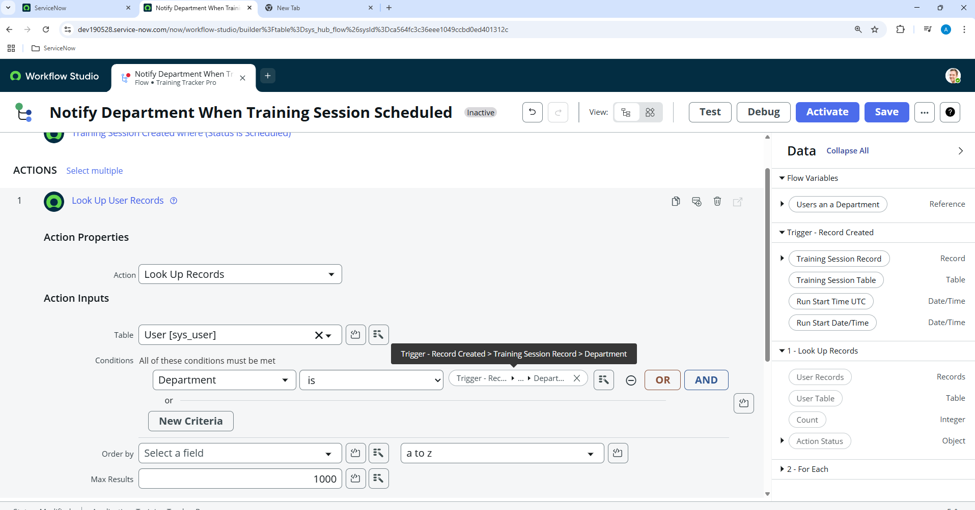

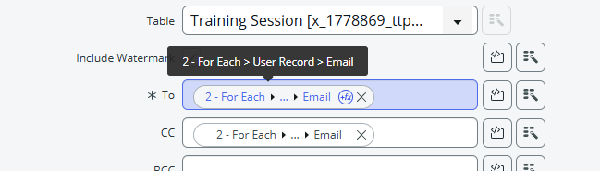

**Inside the look, select Action “Send Email”.**

**Configure “send email” action as following**

**Select “Done”**

**Select “Activate”**

**Test the flow by creating a new Training Record in Training Session table (** *x_1778869_ttp_training_session*)

**Select “Submit”**

**Check email logs:**

**Number of emails triggered = number of Active employees in department “Finance”**

